OIL CONDITION MONITORING REPORT SLNS SHAKTHI

GEAR BOX PARTICULARS(Information provided by the customer)
 | Port Gear Box
Make : | SHICHUAN
Model : | GWC 3235
Sr.No’s: | N/A
Date sampling : 13.02.2019 | 28 Nov 24
Sampling point : | Before filter
Sampling Method : | Extraction
Type of Lubricant : | Caltex Lanka Super DS 40
System Capacity : | 45 Ltrs

RUNNING HRS DETAILS(Information provided by the customer)
 | Port Gear Box
Sample ID | M009165
Oil Running Hours | 684.00
Total Running Hours of the Machinery | 37440.15

ANALYSIS RESULTS

Description | METHOD | Fresh Oil  (As per OEM data sheet) | Uncertainty | Port Gear Box
 |  |  |  | S/I- M009165
Viscosity @ 40ºC (cSt) | ASTM D 445 | 132.31 * | 0.018 Cst | 125.78
Viscosity @ 100ºC (cSt) | ASTM D 445 | 14.4 | 0.018 Cst | 14.21
Viscosity Index | ASTM D 2270 | 97 | N/A | 112.04
* The results were taken from a fresh oil sample which is tested at MTTU laboratory as per ASTM D 445 method.

Elemental Concentration as per ASTM D5185 (ppm)

Element | Maximum Permissible Limit | Fresh Oil Sample | Uncertainty | Port Gear Box
 |  |  |  | S/I- M009165
Fe | 300 | < 1.000 | 2.191 | 35.939
Cr | 15 | < 1.000 | 1.810 | < 1.000
Si | 50 | < 1.000 | 1.021 | < 1.000
Al | 30 | < 1.000 | 1.107 | < 1.000
Pb | 1500 | < 1.000 | 2.918 | 8.647
Cu | 250 | < 1.000 | 1.064 | 20.214
Sn | 50 | < 1.000 | 0.131 | < 1.000
Ni | 30 | < 1.000 | 0.090 | < 1.000

TREND ANALYSIS WITH PREVIOUS REPORTS
 |  | Fresh Oil Sample | Port Gear Box
 |  | Fresh Oil Sample | S/I-M000388 | S/I-M000925 | S/I-M002462 | S/I-M003480 | S/I-M004802 | S/I-M006948 | S/I-M007846 | S/I-M009165
Oil Running Hrs |  | - | 903.15 | 945.50 | 999.35 | 714.40 | 972.00 | 259.55 | 250.0 | 684.00
T/R/H of Machinery |  | - | 32241.15 | 33187.05 | 34337.35 | 35217.55 | 36476.30 | 36747.20 | 37005.45 | 37440.15
Viscosity @ 40ºC (cSt) |  | 132.31 * | N/A | 135.16 | 137.82 | 128.45 | 136.39 | 137.69 | 127.46 | 125.78
Viscosity @ 100ºC (cSt) |  | 14.4 | N/A | 13.86 | 14.15 | 13.38 | 14.05 | 14.38 | 13.94 | 14.21
Viscosity Index |  | 97 | N/A | 98.62 | 99.75 | 98.52 | 99.76 | 102.69 | 106.78 | 112.04
Element | Maximum Permissible Limit
Fe | 300 | < 1.000 | 18.652 | 82.530 | 74.450 | 11.000 | 1.720 | 44.566 | 19.930 | 35.939
Cr | 15 | < 1.000 | < 1.000 | < 1.000 | < 1.000 | < 1.000 | < 1.000 | < 1.000 | < 1.000 | < 1.000
Si | 50 | < 1.000 | 3.916 | 6.251 | 6.525 | 1.189 | < 1.000 | 6.991 | < 1.000 | < 1.000
Al | 30 | < 1.000 | < 1.000 | < 1.000 | < 1.000 | < 1.000 | < 1.000 | < 1.000 | < 1.000 | < 1.000
Pb | 1500 | < 1.000 | 4.442 | 16.036 | 9.210 | 4.445 | < 1.000 | 10.456 | 5.855 | 8.647
Cu | 250 | < 1.000 | 3.373 | 11.004 | 15.193 | 3.263 | 3.308 | 54.787 | 6.879 | 20.214
Sn | 50 | < 1.000 | < 1.000 | < 1.000 | < 1.000 | < 1.000 | < 1.000 | < 1.000 | < 1.000 | < 1.000

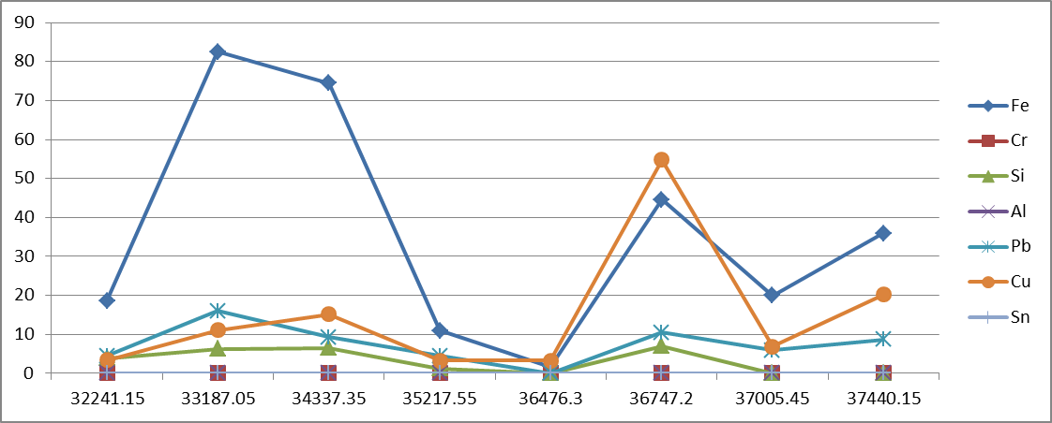
Port

ppm

Total Running Hrs

